**Exploring OFDM using USRP B210**

Report submitted to GITAM (Deemed to be University) as a partial fulfillment of the requirements for the award of the Degree of Bachelor of Technology in EECE



DEPARTMENT OF ELECTRICAL, ELECTRONICS AND COMMUNICATION ENGINEERING

GITAM SCHOOL OF TECHNOLOGY

GITAM (DEEMED TO BE UNIVERSITY)

BENGALURU -561203

NOV 2025

**By:**

**Navyashree J**

**BU22EECE0100455**

**K Sanjana**

**BU22EECE0100457**

**Shreya H B**

**BU22EECE0100463**

**DECLARATION**

We declare that the project work contained in this report is original and it has been done by us under the guidance of my project guide.

Name:

Navyashree J(BU22EECE0100455)

K Sanjana (BU22EECE0100457)

Shreya H B(BU22EECE0100463)

Date:25/09/2025

**Department of Electrical, Electronics and Communication Engineering**

**GITAM School of Technology, Bengaluru-561203**



**CERTIFICATE**

This is to certify that (Navyashree J, K Sanjana, Shreya H B) bearing (BU22EECE0100455, BU22EECE0100457, BU22EECE0100463) has satisfactorily completed Mini Project Entitled in partial fulfillment of the requirements as prescribed by University for VIIth semester, Bachelor of Technology in “Electrical, Electronics and Communication Engineering” and submitted this report during the academic year 2025-2026.

[Signature of the Guide] [Signature of HOD]

**Table of contents**

**Chapter 1: Introduction 1**

* 1. Overview of the problem statement 1
  2. Objectives and goals 1

**Chapter 2: Literature Review 2**

**Chapter 3: Methodology 3**

**References 4**

**Chapter 1: Introduction**

* 1. Overview of the problem statement

How does OFDM perform when implemented with real hardware (USRP B210), under practical RF conditions, and how do various parameter choices affect performance (BER, throughput, spectral efficiency, overhead, etc.

1.2 Objectives and goals

* **Implementation Goal**: Implement a working OFDM transmitter and receiver chain using USRP B210. This includes generation and reception of OFDM symbols, modulation/demodulation, cyclic prefix, IFFT/FFT etc.
* **Synchronization & Channel Estimation**: Develop or use algorithms for timing synchronization (frame detection), frequency offset estimation/correction, and channel estimation / equalization.
* **Parameter Variation and Performance Measurement**: Vary key OFDM parameters (number of subcarriers / FFT size, length of cyclic prefix, modulation schemes e.g. BPSK/QPSK/16‑QAM, pilot spacing, etc.) and measure performance metrics like BER vs SNR (or vs distance / attenuation), throughput, spectral efficiency, possibly latency.
* **Analysis of Hardware / RF Impairments**: Observe how real‑world issues (noise, non‑linearities, phase noise, hardware drift, sample rate limitations, RF front-end limitations) impact OFDM performance.
* **Comparisons with Simulation / Theoretical Predictions**: Compare experimental results with simulations/theory. How much loss is there? Where do assumptions in theory break?
* **Optimization / Recommendations**: Based on the measurements, propose which OFDM parameter settings work best under certain conditions. Possibly suggest modifications or improvements (e.g. choice of cyclic prefix, pilot structure, etc.) for better performance.

**Chapter 2: Literature Review**

A brief survey of relevant work in OFDM implementation using SDRs (especially USRPs), including synchronization, channel estimation, parameter studies and real‑hardware constraints.

2.1 Recent Studies & Implementations

| **Paper / Study** | **Year** | **Key Features / What was Done** | **Why It’s Relevant** |
| --- | --- | --- | --- |
| *Implementation of 2×2 MIMO‑OFDM System using Universal Software Radio Peripherals* | **2020** | Implemented MIMO‑OFDM (2×2 and 2×1) with different IFFT sizes (32, 64, 128) and modulation orders (4‑QAM, 16‑QAM, 64‑QAM), measured BER; used USRP + LabVIEW. ([cvr.ac.in](https://cvr.ac.in/ojs/index.php/cvracin/article/view/606?utm_source=chatgpt.com)) | Good early hardware implementation showing how changing IFFT size & modulation affects BER; useful baseline for  comparison. |
| *Design and implementation in USRP of a preamble‑based synchronizer for OFDM systems* | **2020** | Implemented frame detection, time & frequency synchronisation using preambles in USRP SDR; compared different synchronisation algorithms. ([Papers with Code](https://paperswithcode.com/paper/design-and-implementation-in-usrp-of-a?utm_source=chatgpt.com)) | Important for synchronization section of your project; shows what kinds of offsets and detection methods are practical. |
| *Performance Analysis of an OFDM PHY Scheme with Zero Forcing Equalizer Using Software Defined Radio Platform and USRP* | **2022** (but earlier part of field) | Used USRP‑2920; implemented OFDM with Zero‑Forcing (ZF) equalizer; tested different modulation (M‑PSK, M‑QAM). ([Emitter](https://emitter.pens.ac.id/index.php/emitter/article/view/15?utm_source=chatgpt.com)) | This illustrates equalization methods & modulation effects; helpful to compare with your equalizer / modulation choices. |
| *USRP Based Digital Audio Broadcasting Using OFDM in Virtual and Remote Laboratory* | **2019** | Implemented Digital Audio Broadcasting (DAB) using OFDM, transmitting audio via USRP 2901 & LabVIEW, different modes, controller parameters. ([Online Journals](https://online-journals.org/index.php/i-joe/article/view/8761?utm_source=chatgpt.com)) | Useful for seeing an application of OFDM (audio/data) using USRP; shows parameter choices and challenges in non‑data applications. |
| *A real‑time COFDM transmission system based on the GNU radio* | **2015‑2016 / published around 2015‑16** | Implemented OFDM (COFDM) transmitter & receiver with channel coding in GNU Radio + USRP; compared performance with/without coding under different channel conditions; measured packet failure rate etc. ([ACM Digital Library](https://dl.acm.org/doi/10.1145/2557977.2558050?utm_source=chatgpt.com)) | Good older reference showing how coding + OFDM + SDR behave; you can compare modern hardware / parameter settings to this earlier work. |

2.2 Gaps Relevant to Your Project

* Few studies specifically on **USRP B210** for full OFDM system (TX + RX + parameter sweeps + synchronization + channel estimation).
* Many works use older USRPs (N210, USRP2) or focus only on parts of OFDM (e.g. synchronisation, PAPR).
* Less work (or less published) on the combined effect of hardware constraints (sample rate limits, USB bandwidth, radio front‑end impairments) on BER / spectral efficiency.
* Not many works that explore **cyclic prefix length variation**, **pilot spacing**, **guard band sizes**, etc., in real hardware over different environments (indoor/outdoor).

**Chapter 3: Methodology**

* 1. System Overview

**Transmitter (TX) Chain:**

* 1. Generate a sequence of bits (pseudo‑random or fixed test patterns).
  2. Map bits to symbols (e.g. BPSK, QPSK, 16‑QAM etc.).
  3. Insert pilot symbols or subcarriers (if used) for channel estimation.
  4. Pack symbols into OFDM subcarriers.
  5. Perform IFFT to convert from frequency‑domain to time‑domain.
  6. Add cyclic prefix.
  7. (Optionally) Add preamble / synchronization symbols.
  8. Transmit via USRP B210 (conversion, up‑conversion to RF, amplification etc.).

**Receiver (RX) Chain**:

1. USRP B210 receives RF signal, down converts to baseband, digitizes.
2. (Optional) Filtering, gain adjustment.
3. Synchronization: detect beginning of frame (via preamble), correct timing offset.
4. Estimate and correct frequency offset (CFO).
5. Remove cyclic prefix.
6. Perform FFT (convert back to frequency‑domain).
7. Use pilots (or reference symbols) for channel estimation.
8. Equalize received symbols to mitigate channel distortion.
9. Demodulate, map symbols back to bits.

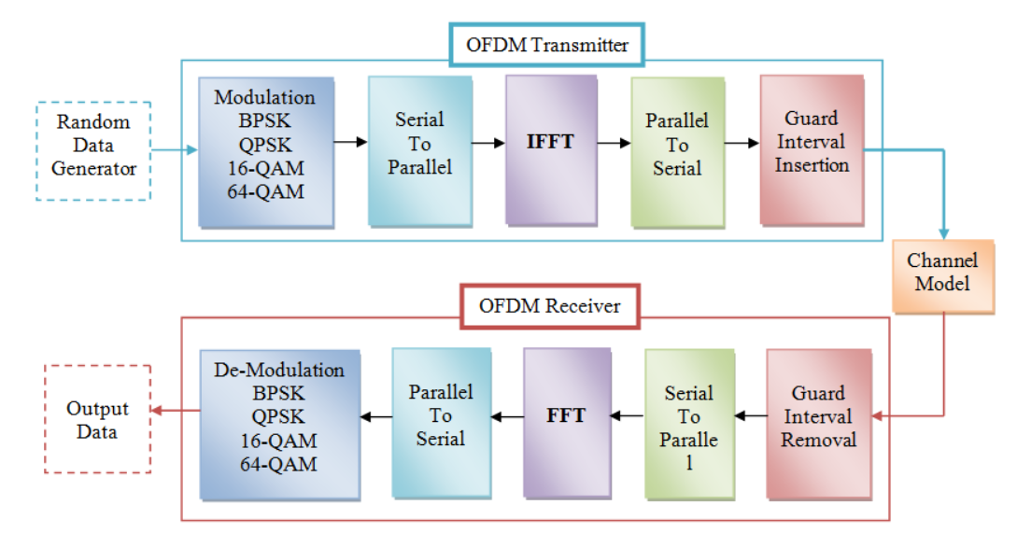

* 1. Hardware and Software Tools
* **Hardware**:
  + USRP B210 SDR for both transmitter and receiver
  + RF front‑end components: antennas, coaxial cables, attenuators if needed.
  + Host computer(s) for signal processing.
* **Software**:
  + GNU Radio (or UHD + custom code) for flowgraphs or blocks.
  + Python / MATLAB tools for data logging, plotting, BER calculation etc.
  + Drivers / firmware for USRP B210 (ensuring sample rate, clock reference stability .

**Chapter 7: Conclusion**

Here write Suggestions for further research or development and Potential improvements or extensions

**Chapter 8 : Future Work**

Here write Suggestions for further research or development Potential improvements or ex